Home Isolation – Process Journal

By Andrew Letailleur

03/12/2020

2020

**Milestone #1,** Documentation/Planning

I started by brainstorming ideas for the serious game, which led to the idea of an artistic, “home isolation” game. I believed I do this within the assigned timeframe, and that the idea can be of historical interest, on what life could have been like in the year 2020.

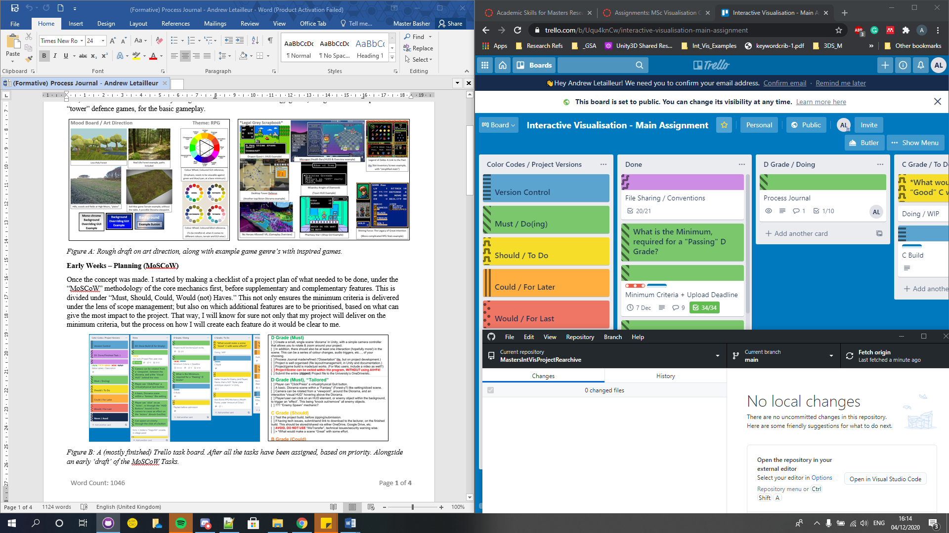  
*\*Figure A: A Screenshot of a (then done) GitHub repository, and Trello board*

Afterwards, it was a matter of setting up a GitHub repository, for both archiving and sharing the project for everyone else within my feedback group. Setting up a task management system, through Trello. Along with sorting out the documentation on how the game itself would work out, before I began development on the game itself. I did two separate documents, one the storyboard, and the other the ‘design document’.

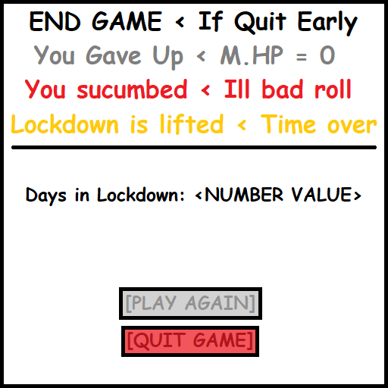 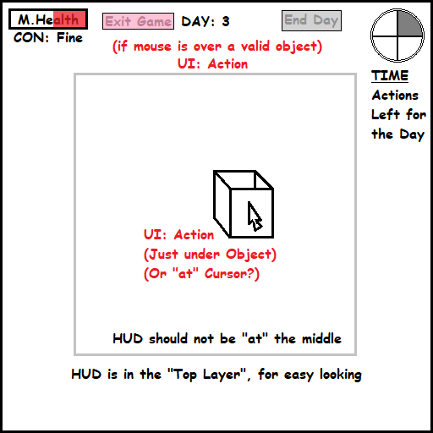 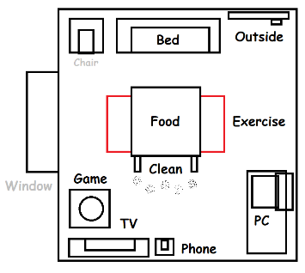  
*\*Figure B: (Some) Storyboard Sketches of the Game Layout*

For the storyboard, I went under a “simplified” MoSCoW Methodology, given the procrastination I had with going more than two “steps” at most in iteration. While the design document was done twice; one under the “One Page Design Document” that included the projected milestones for this project. While a more detailed one was made, to cover all of the requirements as possible within the project brief.

**Milestone #1b,** group feedback

Feedback given, was that though the documentation was superb, and the theme was well presented in terms of topic and originality. How the gameplay would be shown, along with the explanation during the presentation itself, was vague.

I resolved to fix those issues for the next peer review, with a clearer presentation, by planning on using snippets of the developed gameplay to better describe how the gameplay would function as is, alongside a “minimum” and “ideal” view for last minute polish, post development.

**Milestone #2**, framework (Prototype)

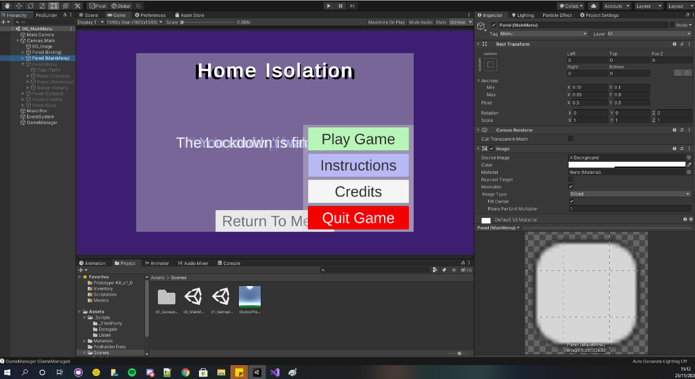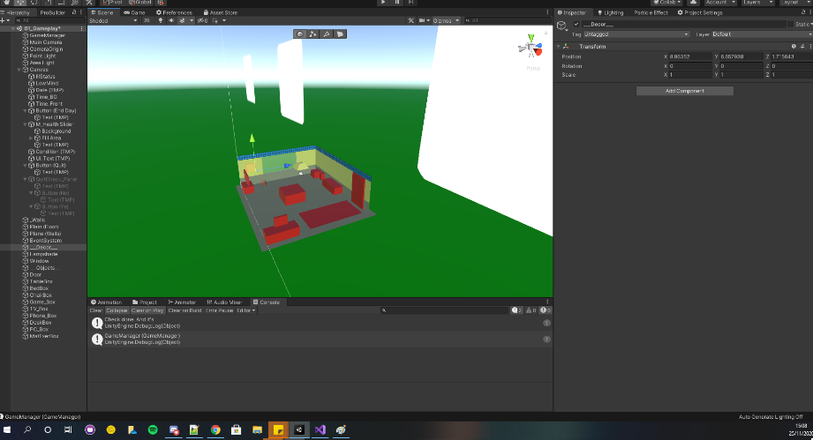  
*\*Figure C: Developer screenshots of Prototype project*

Took three days longer than projected, to finish this. But by the 23rd, I’ve created a playable prototype. With a complete gameplay loop, to an interactive degree. GUI design works as envisioned, that includes the “Day/Time Counter”, mental health, physical condition and GUI Descriptions.

**Milestone #2b**, refinement

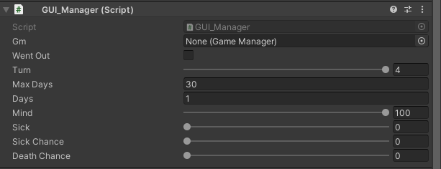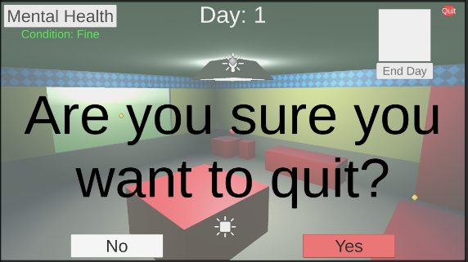  
*\*Figure D: In-dev example, of refined gameplay length, and quit game functionality.*

I spent this day refining the gameplay experience, by adding last base descriptions for all interactions and instructions, and refined the visuals to hint at the player’s current condition, by ailment or current mental health. I also managed to include an in-game “quit” button by this stage, polish wise. Along with some double checking to ensure that there’s beyond a doubt, an “easy quit” loop to exit the game.

Afterwards, for transparency, I focused on commenting all of my code. To ensure that if another developer were to work on the project again, the intent of the code is easily understood, credits from each script given, etc.

**Milestone #3**, User feedback, and Project Refinement

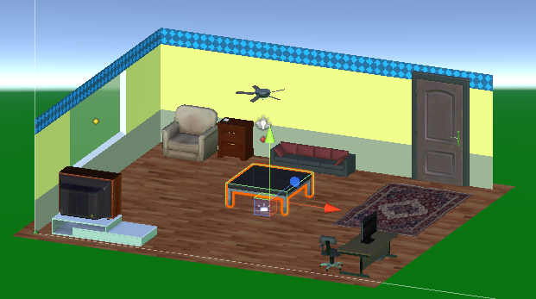 *\*Figure E: In-dev example of the refined gameplay screen (without the ‘soap’ box).*

I had planned to refine the prototype, to be more graphical by the feedback stage, but I focused more on refining the core gameplay, over that. So this priority meshed with the feedback for better contrast to update the models to go from a “prototype” quality, to a more immersive quality.

That said. The verbal feedback on prototype was stellar, along with the presentation itself. Which I see as evidence I acted on earlier feedback on the issues with my first presentation, by having some initial practice on the presentation, before I began.

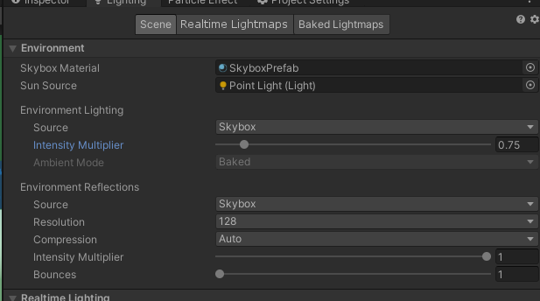  
*\*Figure F: In-dev example, of refined gameplay length, and quit game functionality.*

On top of this, I also got a suggestion to improve the visual contrast of objects as is; which I proceeded to use to not only act on refining the lighting in stage to a more ‘tame’ degree, but also update the visuals to be past a prototype quality, and into an outright good visual standard. Along with adding last minute audio cues within the game itself.

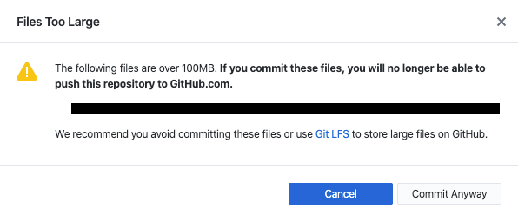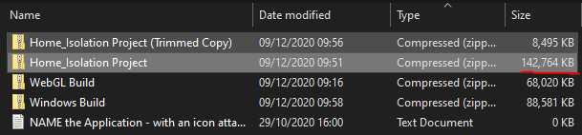  
*\*Figure G: (REDACTED) GitHub Push error log, of “files over 100MB” issue.  
And the (zipped) file in question in file size, contents wise.*

However, issues with GitHub storage became a concern, the moment I included third party assets that drastically went over the limit. This led to being unable to further update my backup, to resolve those issues. This ultimately forced me to “nuke” my current repository, and create a new archive to store all the project data.

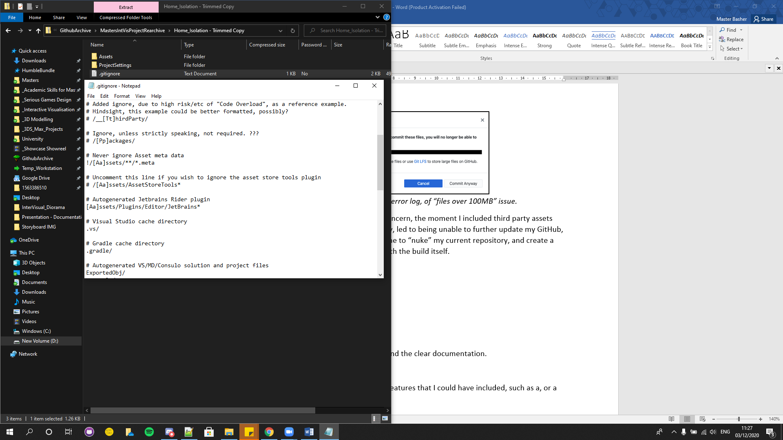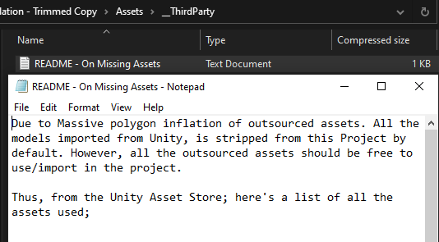  
*\*Figure H: Screenshot example of the zipped, trimmed project for the GitHub archive.*

Once done, I made sure to make the new archive contained only the project settings and assets included. And excluded all “__ThirdParty” assets from the archive that was the root cause for archive issues. Before adding a “README” file explaining why, for a future developer, to re-download the assets from the online store itself. This isn’t ideal, but it was the best I can do, to ensure the project is accessible to everyone.

**Milestone #3b,** Reflection/Process Journal and Final Polish

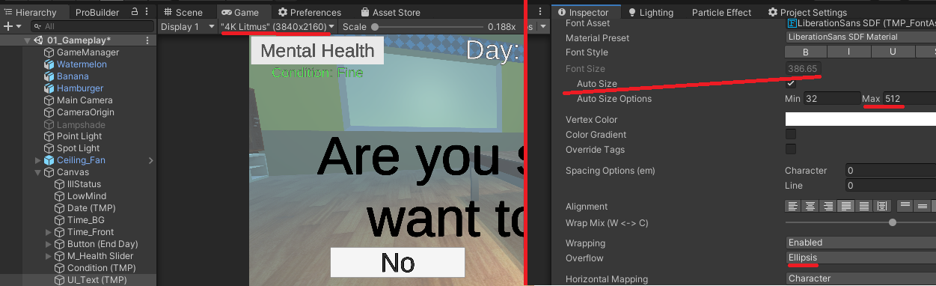  
*\*Figure I: Development Screenshot of Future-proofed GUI, at 4K Resolution*

Lastly, once the initial feedback was acted on; I then concluded by working on this process journal, and implemented last minute polish to act on provided feedback, including fine tuning the GUI to be “future proof” against high resolutions, based on feedback from my formative assessment. I also made a functional WebGL build that I may not be able to share due to file size constraints.

Conclusion

Overall, I am happy with the strong vision I had, my ability to meet the project specification with clear documentation and coding, and having acted on provided feedback. Though in reflection, there were a handful more features that I could have included, such as an options menu. While I had to discard sharing of some assets, due to storage limitations with GitHub. Bar that, I made a playable artistic game to a polished standard. Maybe the game not ‘fun’, but if it’s a playable experience, then I definitely fulfilled the specification of the project brief.

# Appendix: Table of Outsourced Assets

|  |  |  |  |  |
| --- | --- | --- | --- | --- |
| Name | Format | Author | Storage (MB) | Sourced from; |
| **Models** | 3D Object |  |  | Unity Assets Store |
| _Television_Set | “” | Dmitriy Dryzhak | 8.10 MB | “TV Set” |
| AddOns | “” | Unity Technologies | 925 KB (~0.925 MB) | “Food Pack - 3D Microgames Add-Ons” |
| ArchViz Sofa Pack - Lite | “” | Cassdalla | 45.8 MB | ArchViz Sofa Pack - Lite |
| Azerilo | “”, PNG | Azerilo | 3.47 MB | Free Rug Pack |
| JJ_InteriorDoorPack_V1 | “” | Jan Fidler | 19.1 MB | Classic Interior Door Pack 1 |
| LowPolyOfficeProps_LITE | “” | RRFreelance | 1.27 MB | Low Poly Office Props - LITE |
| Tim’s Assets | “” | Tim.H | 52.8 MB | Tim's Assets - Old Ceiling Fan |
| Toon Furniture | “” | Elcanetay | 1.60 MB | Toon Furniture |
| Tv_furniture | “” | Enozone | 16.0 MB | TV Furniture |
|  |  | **Total (MB)** | 203.865 MB |  |
| **Sound** | Audio Files | All sourced under CC0 Licence | Storage (KB) | Freesound.org |
| 56309__q-k__rain-04 | WAV | “Q.K.” | 5.204 MB | Rain_04.wav |
| 151217__owlstorm__cough-3 | WAV | “OwlStorm” | 155 KB | Cough (3) |
| 511435__theojt__spooky-music | MP3 | “theojt” | 566 KB | Spooky Music |
|  |  | **Total (MB)** | 5.925 MB |  |
| **Scripts** | Script/Code Language |  | Storage (KB) | Glasgow School of Art - Lectures |
| DragOrbitImproved | C# | Brian Loranger | **“1 KB”** | “” |

**Total MB Outsourced: 209.791 MB**